**Shop EZ: E-commerce Application**

**-using MERN**

**[Screenshots of installation and execution process]**

**Setup Instructions**

**Prerequisites**

Before starting, ensure that your system has the following software dependencies installed:

1. **Node.js and npm**: Node.js is required to run the JavaScript code for both the backend server and frontend React application. npm (Node Package Manager) is needed to install packages.
   * **Installation**: [Download Node.js and npm](https://nodejs.org/) and follow the instructions based on your operating system.
   * **Verify Installation**: Open a terminal or command prompt and type node -v and npm -v to confirm that both are installed.
2. **MongoDB**: MongoDB is used as the database for *The Shop EZ*. You can either use a local MongoDB instance or set up a MongoDB Atlas account for a hosted database.
   * **Installation** (local): [Download MongoDB](https://www.mongodb.com/try/download/community) and follow the setup instructions based on your operating system.
   * **Optional**: For a hosted database, create a MongoDB Atlas account at [MongoDB Atlas](https://www.mongodb.com/cloud/atlas) and follow the instructions to set up a cluster.

**Step-by-Step Setup Instructions**

**Step 1: Install Dependencies**

The project is divided into two main folders: client for the React frontend and server for the Node.js backend. Each folder has its own set of dependencies that need to be installed.

1. **Backend Dependencies**:
   * Navigate to the server folder: **cd server**
   * Install the backend dependencies listed in package. json by running **npm install**

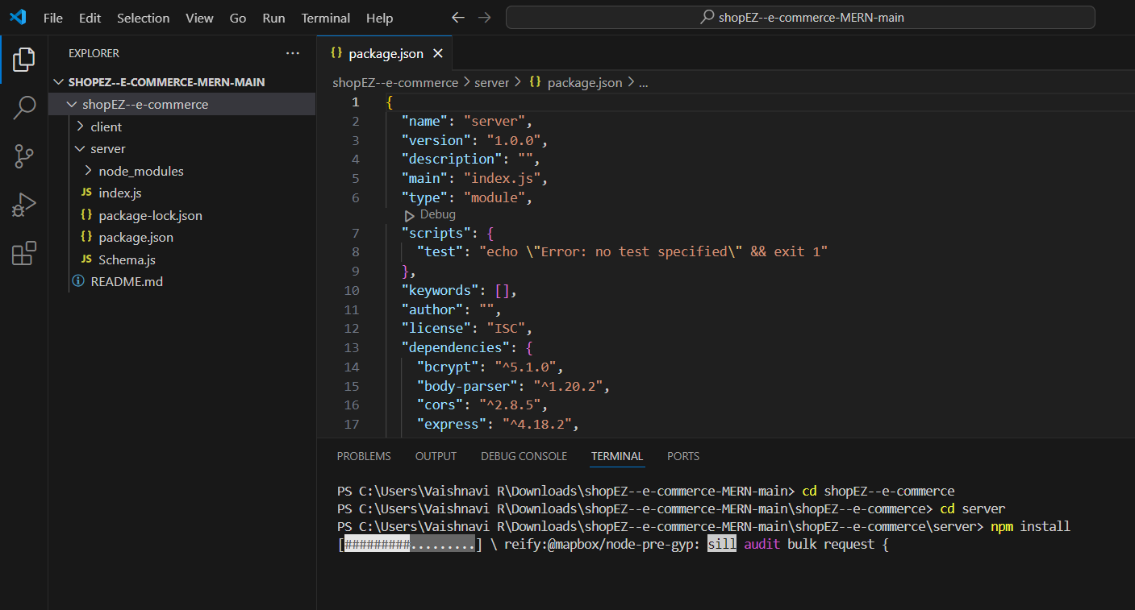

**2.Frontend Dependencies**:

* + Open a new terminal window and navigate to the client folder: **cd client**
  + Install the frontend dependencies by running: **npm install**

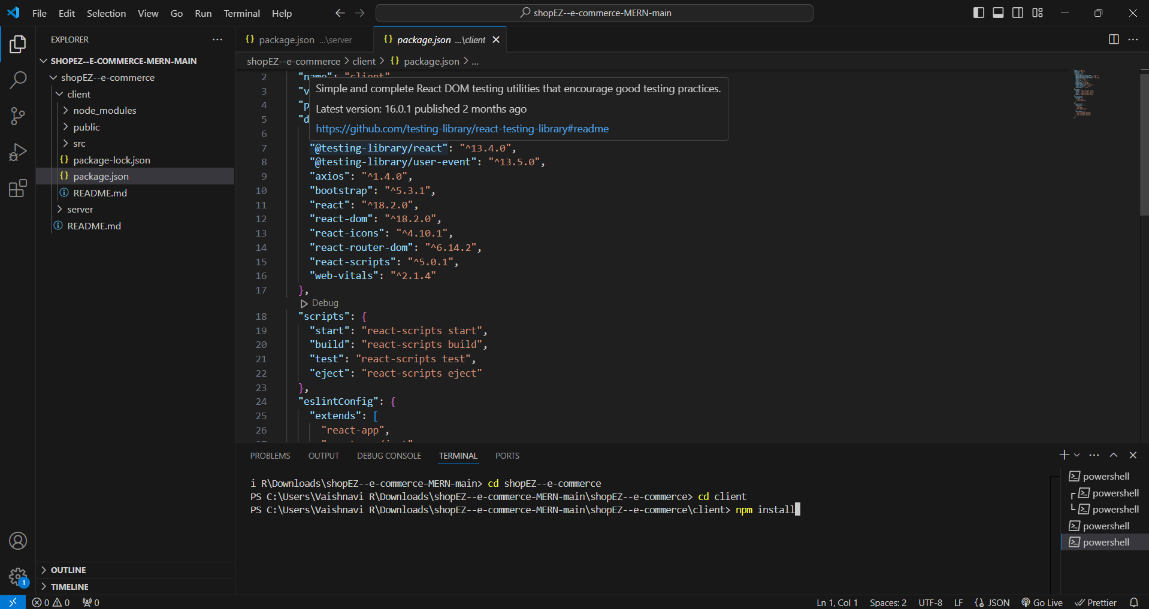

**Step 2: Start the Application**

After configuring the environment variables and installing dependencies, you can start the backend and frontend servers.

1. **Starting the Backend Server**:
   * In the terminal, navigate to the server folder if you’re not already there and run: **npm start**
   * This command will start the backend server on the port specified in the .env file (typically port 5000). You should see output in the terminal confirming that the server is running and connected to the MongoDB database.
2. **Starting the Frontend Server**:
   * In another terminal window, navigate to the client folder and run: **npm start**
   * This will start the React development server, typically running on port 3000.

**Step 3: Verify Database Connection**

To ensure the database is connected correctly, navigate to the MongoDB collections and check if any initial data is available. Additionally, you can confirm database connectivity by checking for log messages in the backend terminal indicating a successful connection.

1. **Folder Structure**

* **Client (Frontend)**:

**Src**

* + - **components**: Reusable UI components like ProductCard, CartItem, and OrderSummary
    - **pages**: Full-page views such as ProductList, ProductDetails, Cart, Checkout, and Dashboard.
    - **services**: Handles API calls to the backend for CRUD operations.
    - **styles**: Global stylesheets and CSS modules for specific components.
    - **utils**: Utility functions for data manipulation and formatting.
* **Server (Backend)**:
  + **/routes**: Contains endpoint routes for users, products, cart, orders, and authentication.
  + **/controllers**: Business logic functions for handling requests, such as order processing or cart updates.
  + **/models**: Mongoose schemas representing database collections (e.g., User, Product, Order).
  + **/middlewares**: Middleware for authentication, error handling, and validation.
  + **/config**: Configuration files for database connection and environment variables.
* **Back-end functionality Front-end functionality**

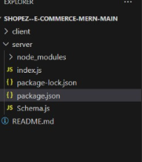 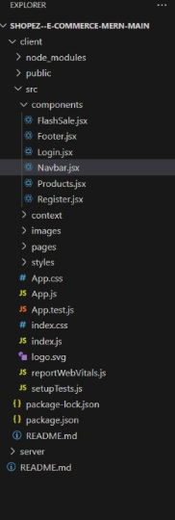

Database:

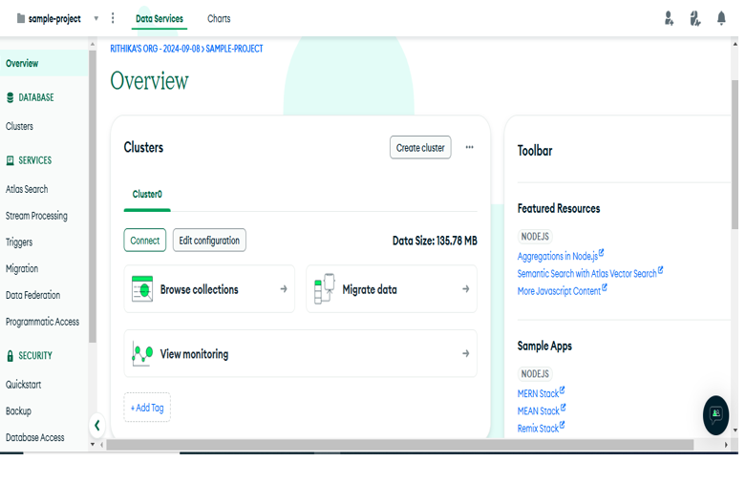**Project execution**

**Running the Application**

**Commands to Start Servers**:

**Frontend**: **cd client >>npm start**

**Backend: cd server >>npm start**

Front-end:

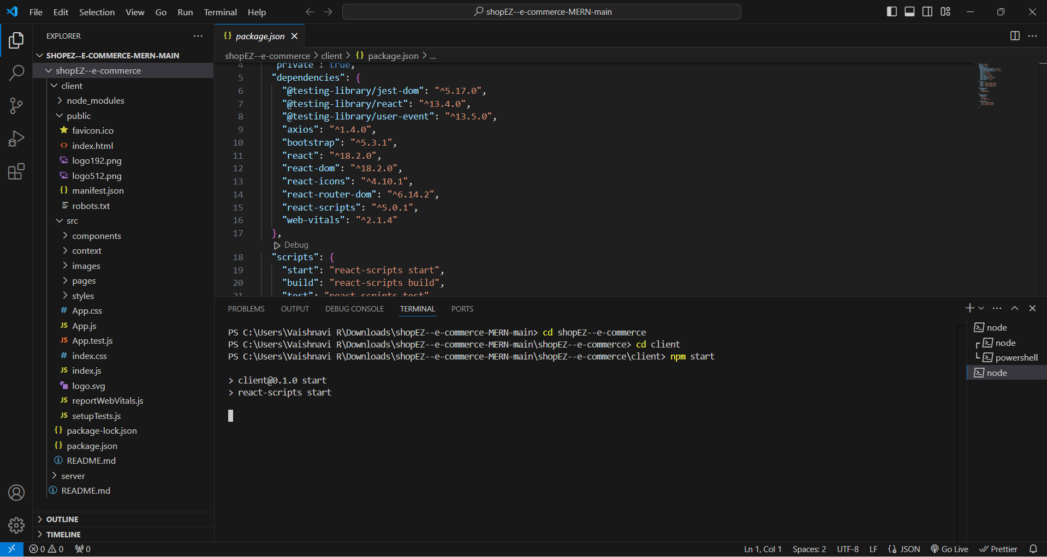

Back-end:

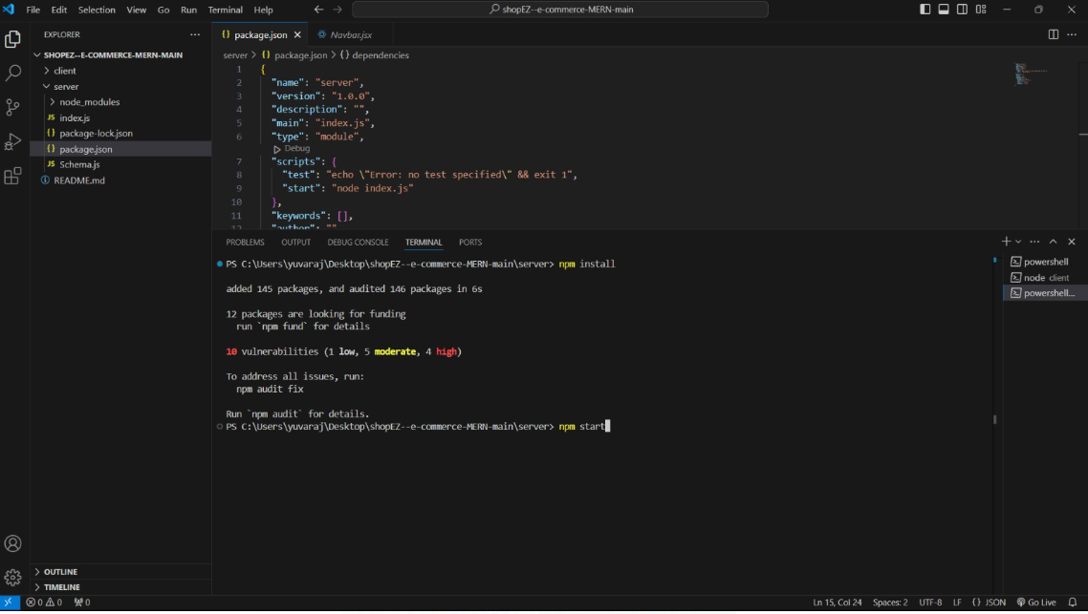

Database:

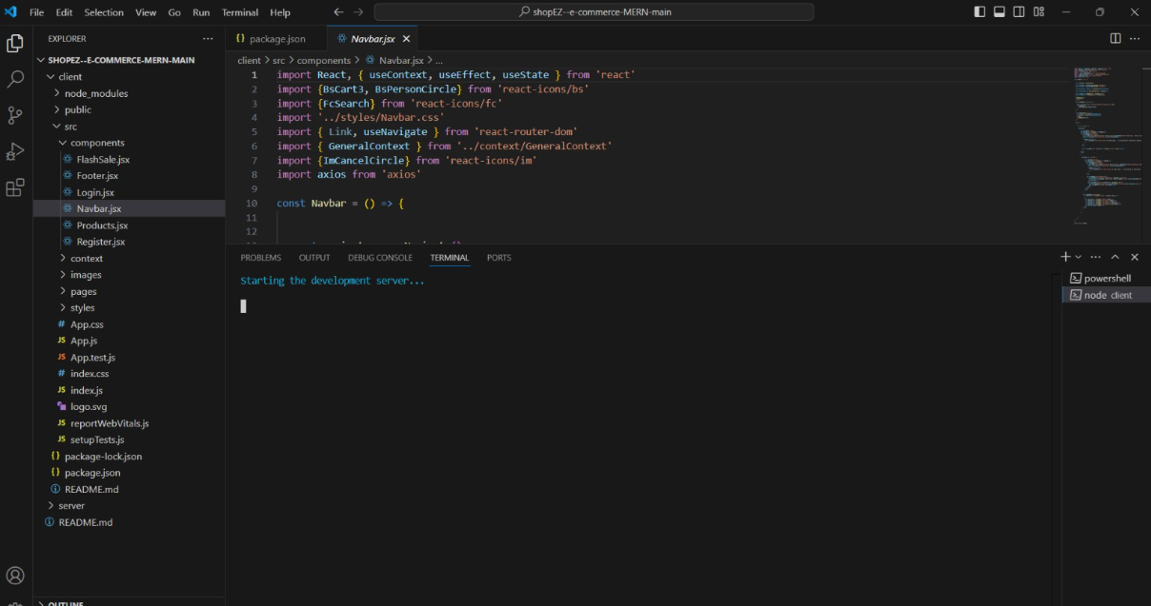

**OUTPUT :**

**The home page**

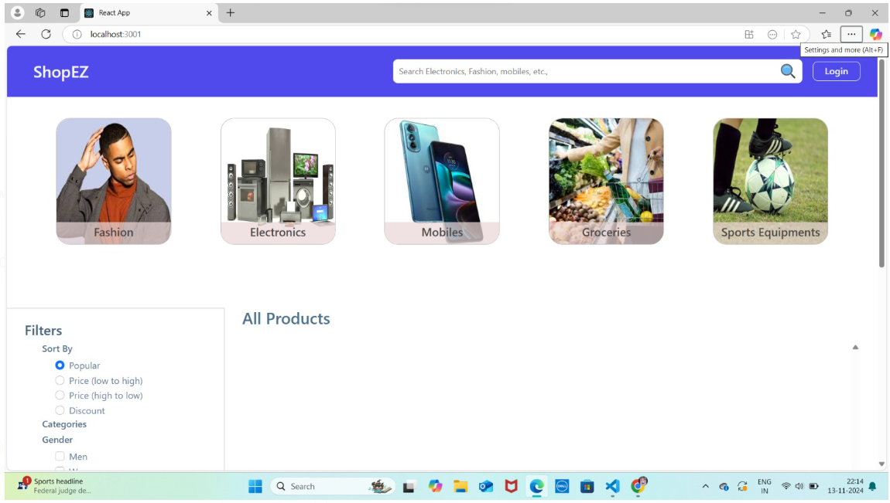

**Sign-up page**

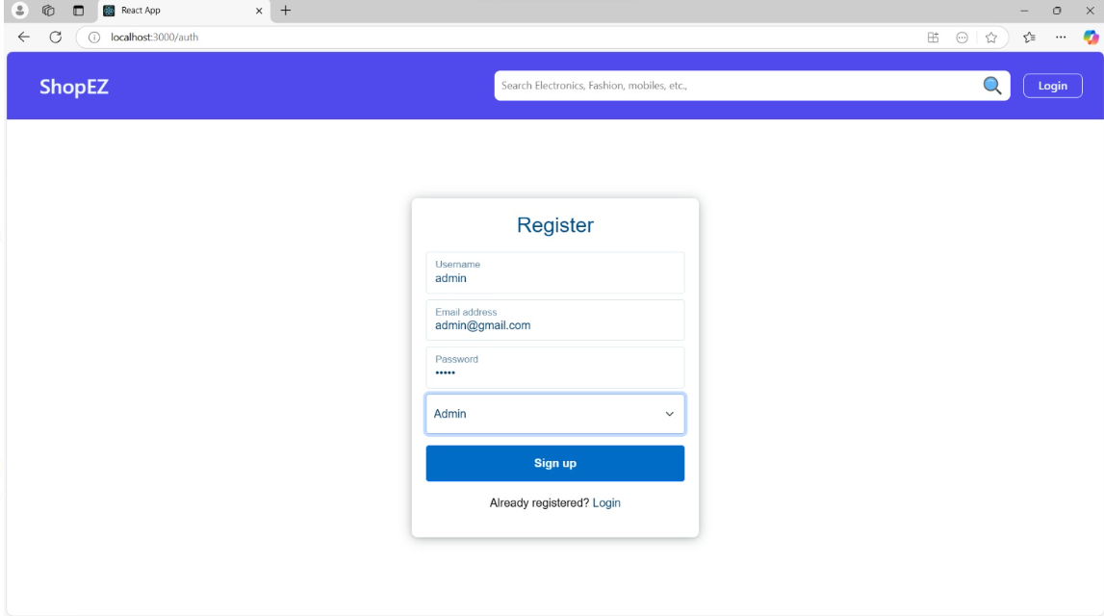

**Login page**

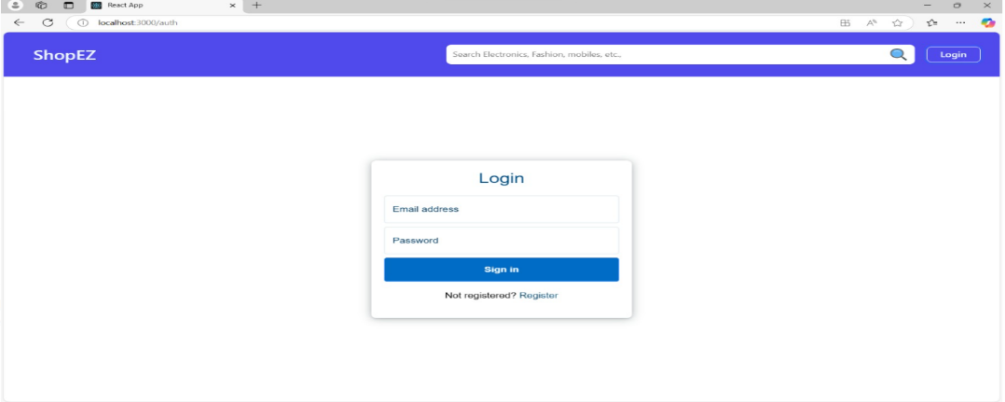

**Admin**

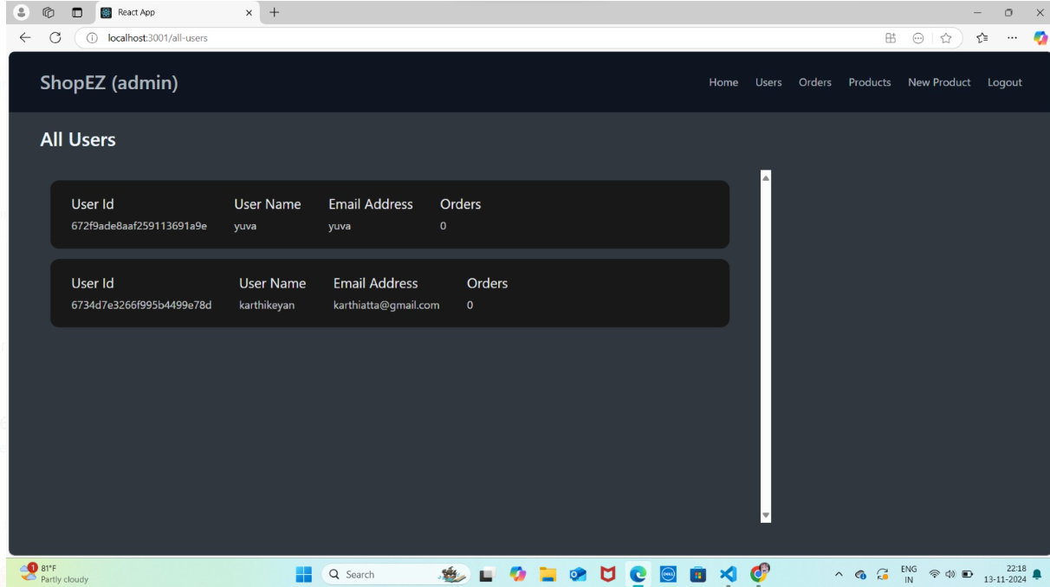

**All Products**

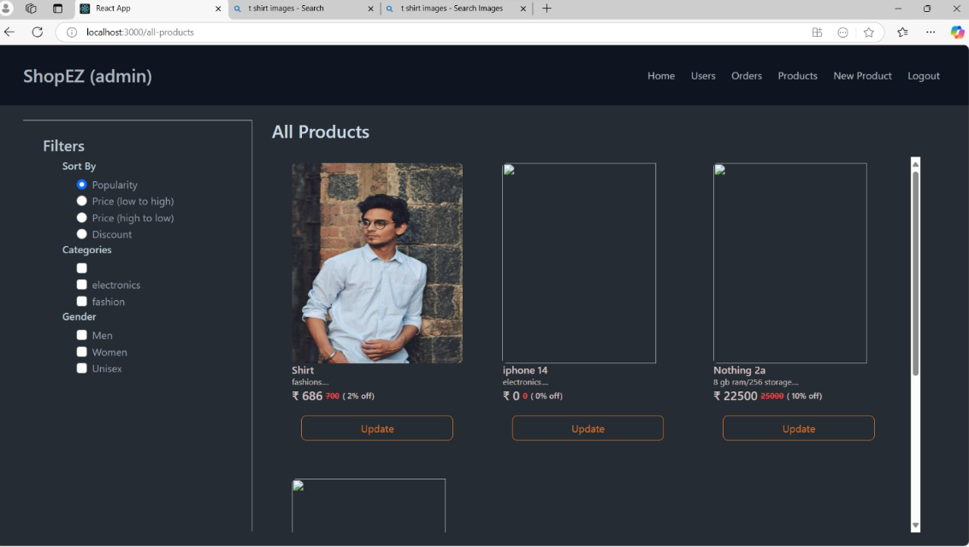

**NEW PRODUCTS**

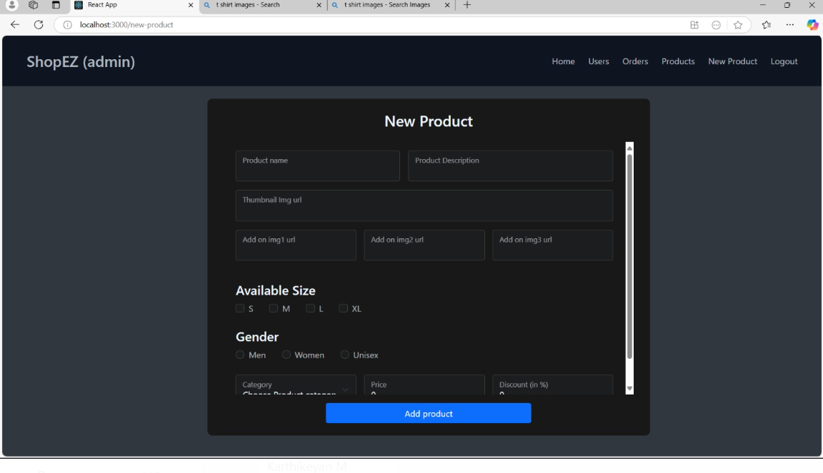

**Add to cart**

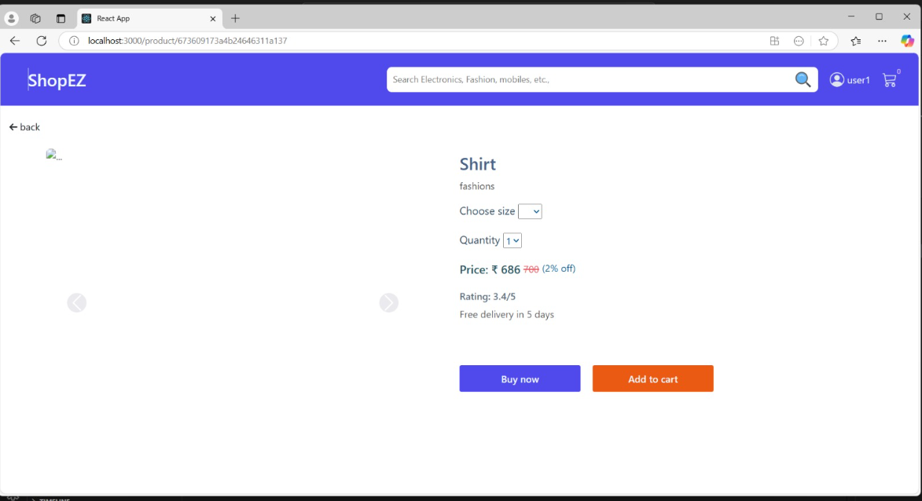

**Payment**

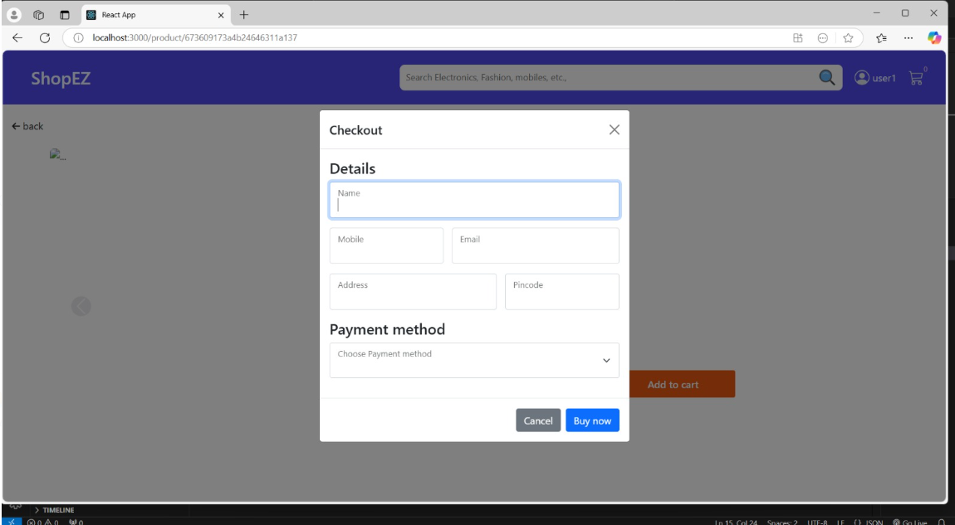

**Orderd product details**

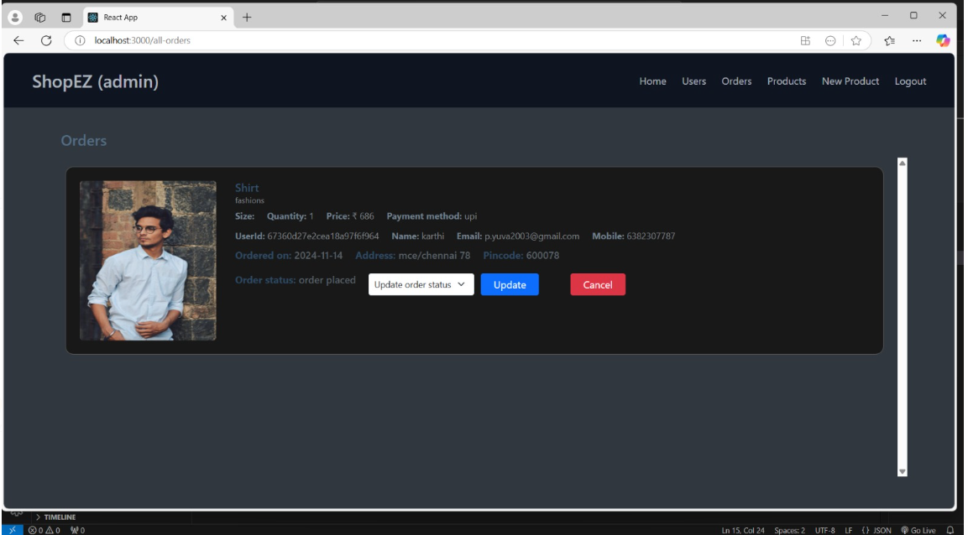

**Number of order placed**

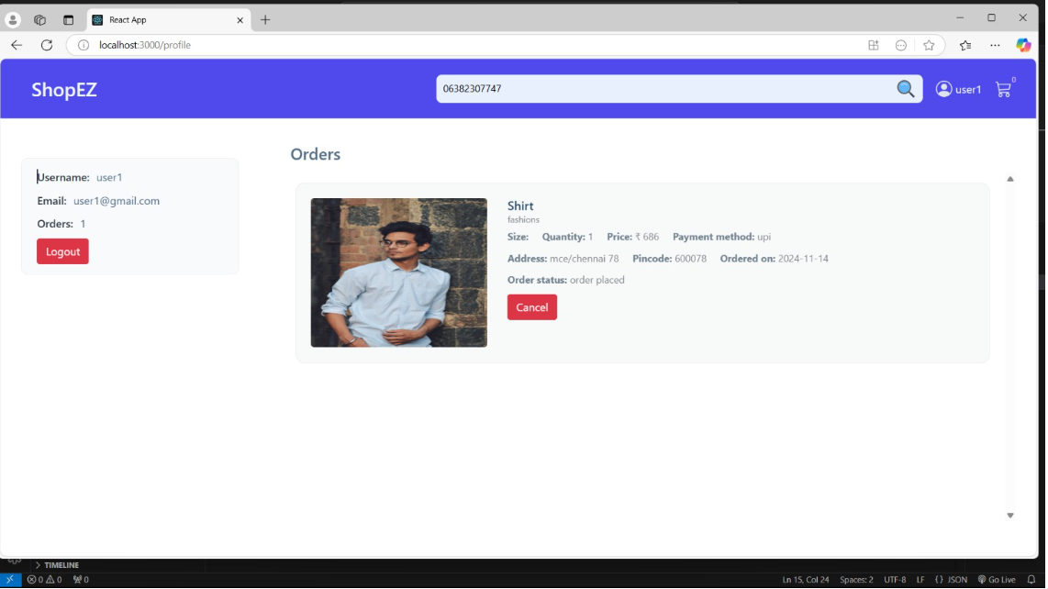

**Logout**

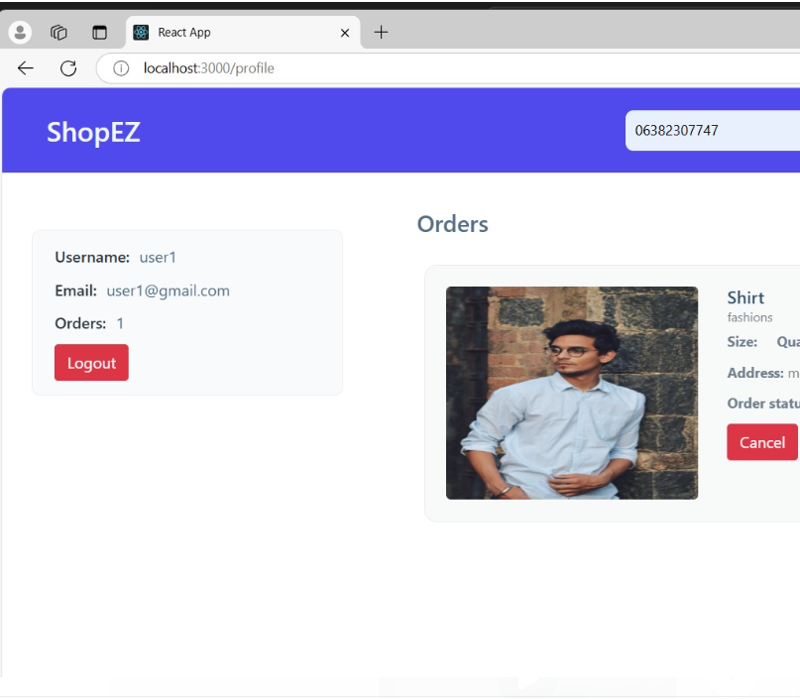

**Database**

